**DESIGN PROJECT LT F-E**

1. Build up with : JAVA
2. Game: Pikachu
   1. UI

* main menu:

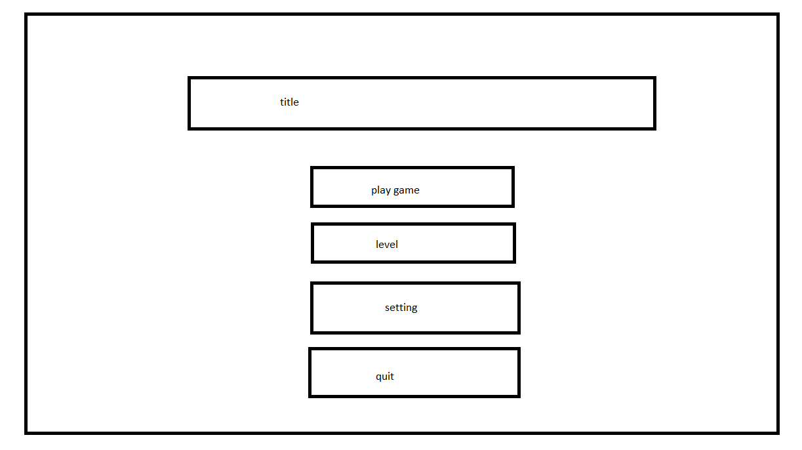

-play game

-level

-setting

-quit

*in game:

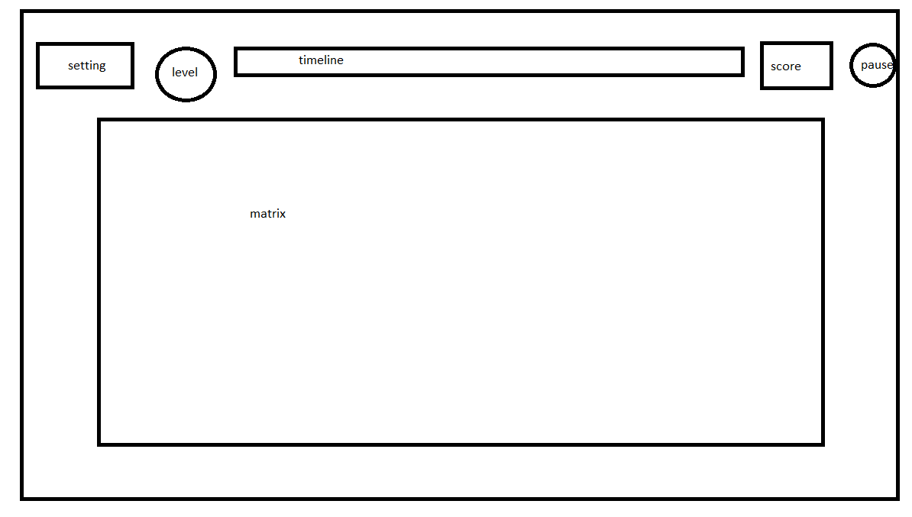

-image:

-pause:-setting:

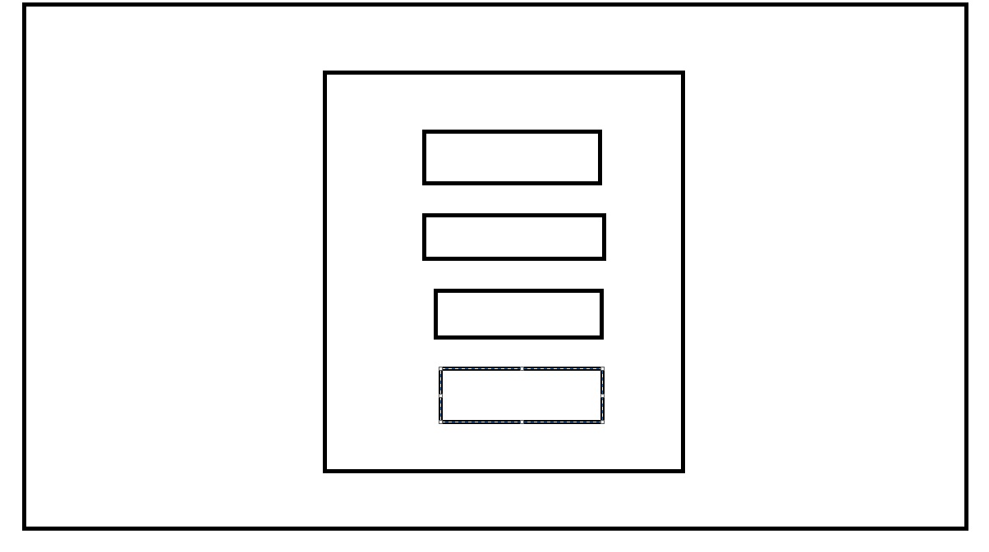

-time

-level playing

-score

* 1. Controll

* Code :

-ui:

+ main game

+ game playing

+pause

+level

+setting

-state game: main menu, game playing,pause

- listener controll

- click mouse, press key, button

-algorithm use,matrix

* 1. Diagram code

1. Build source:

-set up source code

-back up

-git

1. Readme

-document

-game play

* game development:

- coin game

-win a level : +50 coin

* game exception:

-reset matrix (if matrix false)

- sucgess (1 time : 10 coin)